Section slides: <http://webdev.slides.com/coltsteele/mysql-106#/19>

* In this section we’ll be inserting a ton of data into our Instagram database schema, then asking some questions that we’ll need to answer using the techniques we’ve learned in this class

# Inserting the Dataset

* For this section we’ll use the ig_clone_data.sql file that the instructor has created
* It consists of thousands of likes, 21 different hashtags, a couple hundred photos, and 100 users

# Instagram Clone Challenge 1 – The 5 Most-Tenured Users

* Suppose we want to reward our users who have been around the longest. **Find the 5 oldest users**.
* This can be accomplished simply be listing out all the users, sorting them by the **created_at** timestamp, and limiting the output to 5



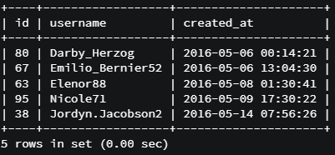

* Solution code

SELECT *

FROM users

ORDER BY created_at

LIMIT 5;

# Instagram Clone Challenge 2 -